**Web Designing**

* A web design service provides you with a customized website design that's perfect for your business or personal site. They'll work with you to create a design that matches your brand, while giving your customers a seamless user experience that will delight them.

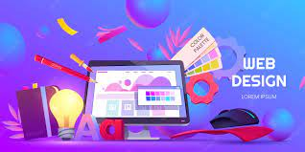

* Basically, it involves building webs & designing domain registration, email registering, and server hostings. In recent years, web designing companies extend their services to design consultation, testing, and maintenance, and technical analysis of your product.
* Some important services that these web designing companies provides that is –
* Mobile App Development
* Lead Generation
* Enterprise Software Development
* Software Development
* Social Media Marketing
* PPC
* SEO
* Digital Marketing

There are different types of web designing are available. They are-

* Static website. ...
* Dynamic website. ...
* Responsive design. ...  
  **Static website designing-**

Our Static Web Design service starts with understanding and analyzing the client’s business requirement. Once this analyzing phase is over, our creative web designer will design the appropriate design layout which translates your business logic into the desired web application.

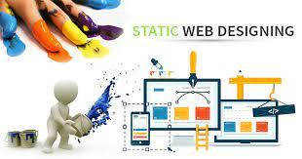

Moreover, once the design layout is completed and approved by our client, then our web designer gives you a unique and personalized web design with high quality. In addition to this, we also help to choose web hosting and set up your website which is globally visible.

**Dynamic website Designing-**

A dynamic website is designed to serve different content to different users based on a variety of factors, such as user preferences, selection, and time zone. Needless to say, this can be a very powerful feature.

In this article, we’re going to cover the differences between a static and a dynamic website, the benefits of a dynamic website, and the technologies needed to develop one.



**Responsive design-**

Responsive web design is about creating web pages that look good on all devices!

A responsive web design will automatically adjust for different screen sizes and viewports.

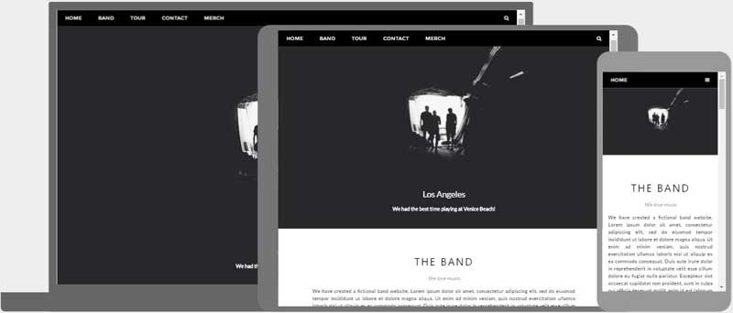

Responsive Web Design

What is Responsive Web Design?

Responsive Web Design is about using HTML and CSS to automatically resize, hide, shrink, or enlarge, a website, to make it look good on all devices (desktops, tablets, and phones).